Mac learning:

Switch maintain an address table called the mac table. when the switch receive the frame the sender device also send its mac address and reached to its destination port after the message is received the receiver also send the acknowledgement signal to the receiver with its mac address. Switch by default save the mac address.

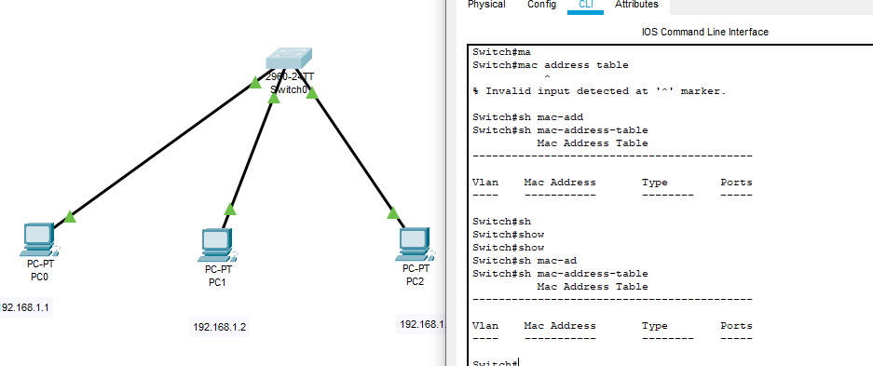

We haven’t connected any device to each other so we cannot get mac address.

* If we ping pc0 to pc3 then and pc3 to pc0

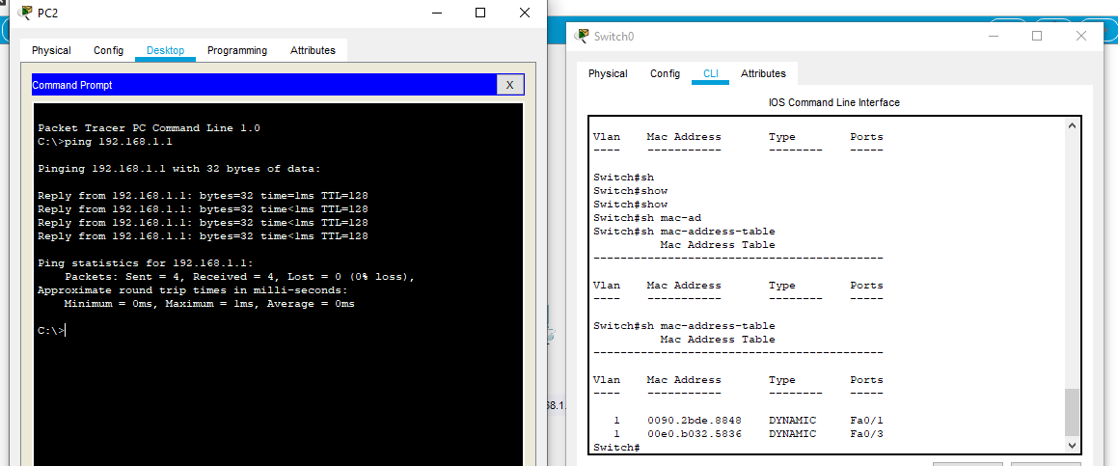

Frame switching:

In switch data are transmitted in the form of frames. The main task of switch is to forward the packets based on the three conditions store and forward switch, cut through switch, fragment through switch.

* In store and forward switch it store all the frame in internal memory and check whether there is any error or not before forwarding the packet to its destination. A cut-through switch reduces delay because the switch begins to forward the frame as soon as it reads the destination MAC address and determines the outgoing switch port.
* Fragment-free switching works like cut-through switching with the exception that a switch in fragment-free mode stores the first 64 bytes of the frame before forwarding.